1. What is the internet?

The Internet is a computer network that interconnects hundreds of millions of computing devices throughout the world.

In Internet jargon, all of these devices are called hosts or end systems.

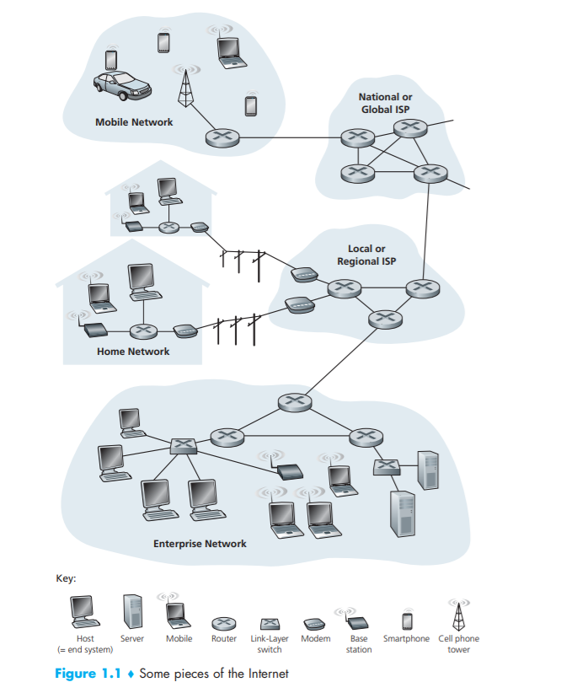

End systems are connected together by a network of communication links and packet switches.

Different links can transmit data at different rates, with the transmission rate of a link measured in bits/second.

The resulting packages of information, known as packets in the jargon of computer networks, are then sent through the network to the destination end system, where they are reassembled into the original data.

Packet switches come in many shapes and flavors, but the two most prominent types in today’s Internet are routers and link-layer switches.

The sequence of communication links and packet switches traversed by a packet from the sending end system to the receiving end system is known as a route or path through the network.

End systems access the Internet through Internet Service Providers (ISPs), including residential ISPs such as local cable or telephone companies; corporate ISPs; university ISPs; and ISPs that provide WiFi access in airports, hotels, coffee shops, and other public places.

End systems, packet switches, and other pieces of the Internet run protocols that control the sending and receiving of information within the Internet. The Transmission Control Protocol (TCP) and the Internet Protocol (IP) are two of the most important protocols in the Internet.

The Internet’s principal protocols are collectively known as TCP/IP.

Internet standards are developed by the Internet Engineering Task Force (IETF)[IETF 2012]. The IETF standards documents are called requests for comments (RFCs). RFCs started out as general requests for comments (hence the name) to resolve network and protocol design problems that faced the precursor to the Internet

End systems attached to the Internet provide an Application Programming Interface (API) that specifies how a program running on one end system asks the Internet infrastructure to deliver data to a specific destination program running on another end system. This Internet API is a set of rules that the sending program must follow so that the Internet can deliver the data to the destination program

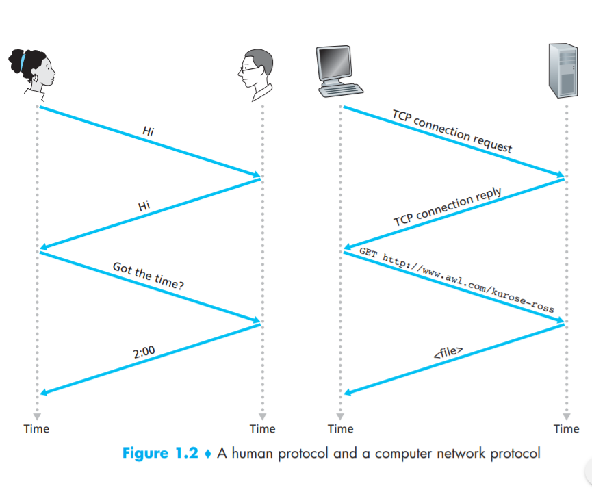

A protocol defines the format and the order of messages exchanged between two or more communicating entities, as well as the actions taken on the transmission and/or receipt of a message or other event.

Throughout this book we will use the terms hosts and end systems interchangeably; that is, host = end system. Hosts are sometimes further divided into two categories: clients and servers.

Today, the two most prevalent types of broadband residential access are digital subscriber line (DSL) and cable

